RGB LED Color Mixing

This project will be using an RGB LED to scroll through a variety of colors.  RGB stands for Red, Green and Blue and this LED has the ability to create nearly unlimited color combinations.

Hardware Required

* Arduino Uno
* USB A-to-B Cable
* Breadboard
* RGB LED
* 220 Ω Resistors
* Jumper Wires

Circuit

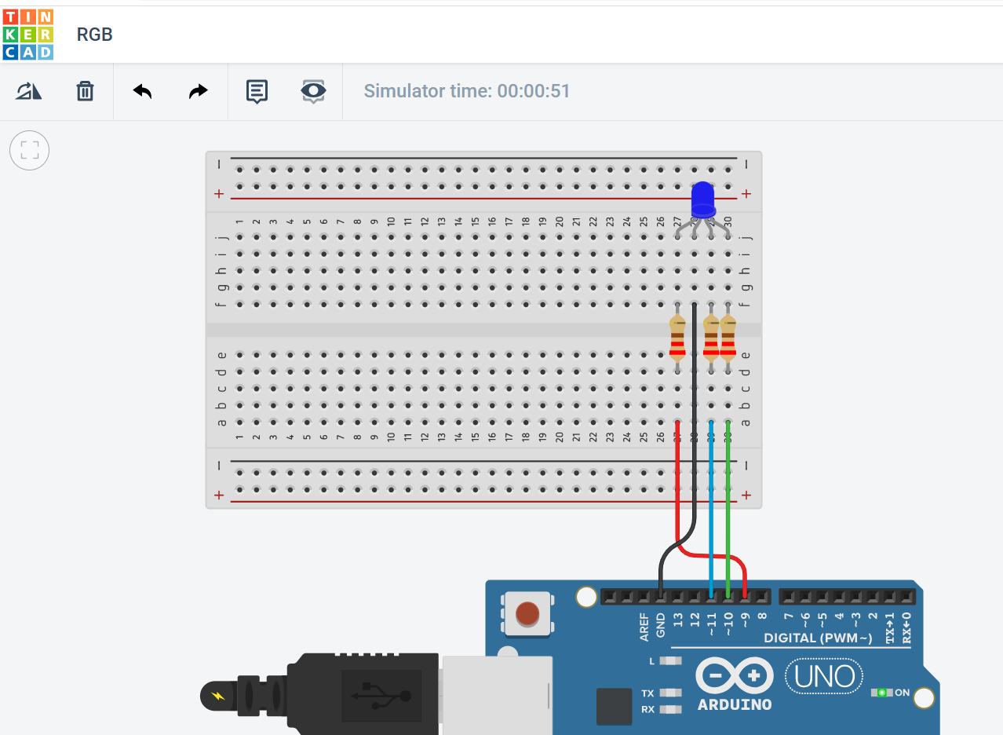

Project Code

// Make an RGB LED display a rainbow of colors!

const int RED_PIN = 9;

const int GREEN_PIN = 10;

const int BLUE_PIN = 11;

const int DISPLAY_TIME = 1000;

void setup()

{

 pinMode(RED_PIN, OUTPUT);

 pinMode(GREEN_PIN, OUTPUT);

 pinMode(BLUE_PIN, OUTPUT);

}

void loop()

{

 mainColors();        // Red, Green, Blue, Yellow, Cyan, Purple, White

 showSpectrum();    // Gradual fade from Red to Green to Blue to Red

}

/******************************************************************

* void mainColors()

* This function displays the eight "main" colors that the RGB LED

* can produce. If you'd like to use one of these colors in your

* own sketch, you can copy and paste that section into your code.

/*****************************************************************/

void mainColors()

{

 // all LEDs off

 digitalWrite(RED_PIN, LOW);

 digitalWrite(GREEN_PIN, LOW);

 digitalWrite(BLUE_PIN, LOW);

 delay(DISPLAY_TIME);

 // Red

 digitalWrite(RED_PIN, HIGH);

 digitalWrite(GREEN_PIN, LOW);

 digitalWrite(BLUE_PIN, LOW);

 delay(DISPLAY_TIME);

 // Green

 digitalWrite(RED_PIN, LOW);

 digitalWrite(GREEN_PIN, HIGH);

 digitalWrite(BLUE_PIN, LOW);

 delay(DISPLAY_TIME);

 // Blue

 digitalWrite(RED_PIN, LOW);

 digitalWrite(GREEN_PIN, LOW);

 digitalWrite(BLUE_PIN, HIGH);

 delay(DISPLAY_TIME);

 // Yellow (Red and Green)

 digitalWrite(RED_PIN, HIGH);

 digitalWrite(GREEN_PIN, HIGH);

 digitalWrite(BLUE_PIN, LOW);

 delay(DISPLAY_TIME);

 // Cyan (Green and Blue)

 digitalWrite(RED_PIN, LOW);

 digitalWrite(GREEN_PIN, HIGH);

 digitalWrite(BLUE_PIN, HIGH);

 delay(DISPLAY_TIME);

 // Purple (Red and Blue)

 digitalWrite(RED_PIN, HIGH);

 digitalWrite(GREEN_PIN, LOW);

 digitalWrite(BLUE_PIN, HIGH);

 delay(DISPLAY_TIME);

 // White (turn all the LEDs on)

 digitalWrite(RED_PIN, HIGH);

 digitalWrite(GREEN_PIN, HIGH);

 digitalWrite(BLUE_PIN, HIGH);

 delay(DISPLAY_TIME);

}

/******************************************************************

* void showSpectrum()

*

* Steps through all the colors of the RGB LED, displaying a rainbow.

* showSpectrum() calls a function RGB(int color) that translates a number

* from 0 to 767 where 0 = all RED, 767 = all RED

*

* Breaking down tasks down into individual functions like this

* makes your code easier to follow, and it allows.

* parts of your code to be re-used.

/*****************************************************************/

void showSpectrum()

{

 for (int x = 0; x <= 767; x++)

 {

   RGB(x);      // Increment x and call RGB() to progress through colors.

   delay(10);

 }

}

/******************************************************************

* void RGB(int color)

*

* RGB(###) displays a single color on the RGB LED.

* Call RGB(###) with the number of a color you want

* to display. For example, RGB(0) displays pure RED, RGB(255)

* displays pure green.

*

* This function translates a number between 0 and 767 into a

* specific color on the RGB LED. If you have this number count

* through the whole range (0 to 767), the LED will smoothly

* change color through the entire spectrum.

*

* The "base" numbers are:

* 0   = pure red

* 255 = pure green

* 511 = pure blue

* 767 = pure red (again)

*

* Numbers between the above colors will create blends. For

* example, 640 is midway between 512 (pure blue) and 767

* (pure red). It will give you a 50/50 mix of blue and red,

* resulting in purple.

/*****************************************************************/

void RGB(int color)

{

 int redIntensity;

 int greenIntensity;

 int blueIntensity;

 color = constrain(color, 0, 767); // constrain the input value to a range of values from 0 to 767

   // if statement breaks down the "color" into three ranges:

 if (color <= 255)       // RANGE 1 (0 - 255) - red to green

 {

   redIntensity = 255 - color;    // red goes from on to off

   greenIntensity = color;        // green goes from off to on

   blueIntensity = 0;             // blue is always off

 }

 else if (color <= 511)  // RANGE 2 (256 - 511) - green to blue

 {

   redIntensity = 0;                     // red is always off

   greenIntensity = 511 - color;         // green on to off

   blueIntensity = color - 256;          // blue off to on

 }

 else                    // RANGE 3 ( >= 512)- blue to red

 {

   redIntensity = color - 512;         // red off to on

   greenIntensity = 0;                 // green is always off

   blueIntensity = 767 - color;        // blue on to off

 }

 // "send" intensity values to the Red, Green, Blue Pins using analogWrite()

 analogWrite(RED_PIN, redIntensity);

 analogWrite(GREEN_PIN, greenIntensity);

 analogWrite(BLUE_PIN, blueIntensity);

}

|  |  |  |  |  |
| --- | --- | --- | --- | --- |
| Your full name | Tel. | Email | Group | Su23 |
| Nguyễn Xuân Trung | 0944353601 | [Trungnxqe170172@fpt.edu.vn](mailto:Trungnxqe170172@fpt.edu.vn) | 2 – SE17B02 |  |
| Đoàn Nguyễn Huyền Trang | 0344468198 | trangdnhqe170154@fpt.edu.vn |  |  |
| Phan Phương Sinh | 0522991730 | [Sinhppqe170242@fpt.edu.vn](mailto:Sinhppqe170242@fpt.edu.vn) |  |  |
| Nguyễn Đồng Lợi | 0702772499 | loindqe170249@fpt.edu.vn |  |  |
| Đường Mỹ Hà | 0901130650 | HaDMQE170046@fpt.edu.vn |  |  |
| Screen shot:    https://www.tinkercad.com/things/gLMI8RfDUfs-rgb-light/editel?sharecode=0AJkD8VFwQ64Ewz9BWpYBvGQ9VQHUzx6bq951IwV9Ds | | | | |
| How it works?  Each LED light consists of three separate chips, each emitting one of the primary colors: red, green, and blue. By controlling the intensity of each color, the LED can produce different shades and hues. By combining red, green, and blue in various proportions, virtually any color can be achieved | | | | |